**MJO Index Computation at ECMWF**

The computation of the MJO index at ECMWF follows the methodology described in Gottschalk et al (2010), except for the fact that here we compute the index on forecast anomalies computed with respect to each model rather than using the NCEP-NCAR reanalysis climatology for all models as in Gottschalk et al. (2010). The procedure is as follows:

**STEP 1: Compute FORECAST/Verification and past 121 day reanalysis anomalies**

**1.1 Verification (re-analysis):**

1. Interpolate U200, U850 and OLR re-analysis for the whole verification period (between 31 and 60 days depending on the model forecast we verify) on a 2.5 x2.5 grid and average the fields between 15N and 15S (each re-analysis date is represented by a record of 144 longitudinal points for each field and each ensemble member)
2. Interpolate U200, U850 and OLR from ERA INTERIM over the past 121 days and average over 15N and 15S.
3. Apply 1) for all the periods starting the same day and month for the common re-forecast period 1999-2010 (all S2S models re-forecasts cover this period). For instance if we verify a 60-day forecast starting on 1st January 2016, we apply 1) to the periods: 1st Jan to 1st March 1999, 1st Jan to 1st March 2000, …. 1st Jan to 1st March 2010.
4. For each year (1999 to 2010) compute the anomalies, by removing the mean of the re-analysis climatology (calculated in 3) to the re-analysis fields computed in 1) corresponding to the verification period. The climatology is calculated by averaging all the re-analysis fields starting the same day and month from 1999 to 2010, but the actual year of the re-forecasts is excluded. For instance, for a re-analysis starting on 1st January 1999, the climatology will contain all the re-analysis fields starting on 1st January 2000-2010.
5. Append the past 121 days anomalies with the anomalies computed in 4)

**1.2 Forecasts:**

1. Interpolate U200, U850 and OLR o on a 2.5 x2.5 grid and average the fields between 15N and 15S (each re-forecast date is represented by a record of 144 longitudinal points for each field and each ensemble member)
2. Interpolate U200, U850 and OLR from ERA INTERIM over the past 121 days and average over 15N and 15S.
3. Apply 1) for all the re-forecasts starting the same day and month for the common re-forecast period 1999-2010 (all S2S models re-forecasts cover this period)
4. For each year (1999 to 2010) compute the anomalies, by removing the ensemble mean of the climatology to the re-forecast ensemble members and ensemble mean. The climatology is calculated by averaging all the reforecasts starting the same day and month from 1999 to 2010, but the actual year of the re-forecasts is excluded. For instance, for a re-forecast starting on 1st January 1999, the climatology will contain all the re-forecasts starting on 1st January 2000-2010. For real-time forecasts, some models (e.g. BoM) have a different frequency for real-time forecasts and re-forecasts. In this case, the climatology used to calibrate the real-time forecasts is computed from the closest 2 re-forecast dates. For instance, the BoM real-time forecast starting on 7 February 2017 is calibrated from the re-forecasts starting on 1st February 1999-2010 and 6 February 1999-2010.
5. Append the past 121 days anomalies with the re-forecasts. See below an example from ECMWF ensemble mean for U200, U850 and OLR for the re-forecast starting on 02/05/2016.

Figure 1: Example ECMWF U200 ensemble mean re-forecasts starting on 2 May 2016:

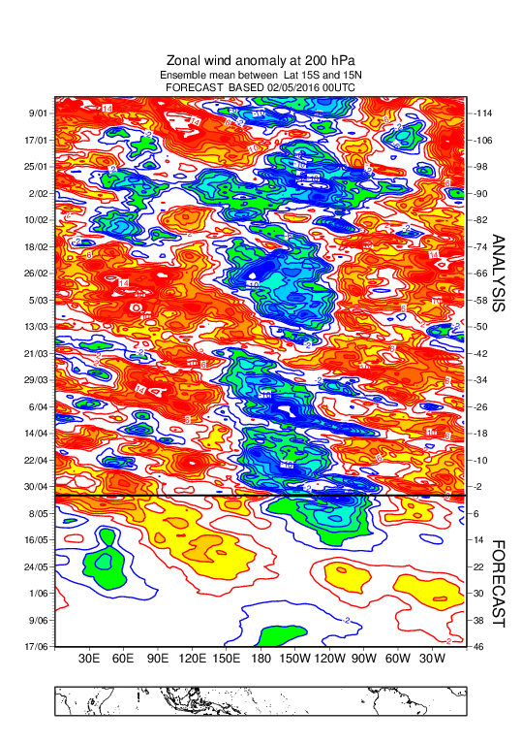

**STEP 2: CEOF Calculation**

1. Normalize U200, U850 and OLR 1-D anomaly fields computed above using the pre-computed coefficients available from BoM
2. Project the U200, U850 and OLR anomaly fields onto the pre-computed combined EOFs to get RMM1 and RMM2
3. Normalise RMM1 and RMM2 using pre-computed coefficients from BoM.
4. Remove the 120-day running mean of the previous 120 days (i.e. a non-centred running-mean). For the past 121 days of rea-analysis, remove the average of the first 120 days.
5. Save the final values of CEOF1 and CEOF2 into ASCII file

This procedure is applied to the ensemble mean and to each individual ensemble member

**Step 3: verification**

Same as above but using OLR, U200 and U850 from ERA INTERIM or ERA5

The procedure described above is applied the same way to all the models.

**Appendix:**

* For forecasts starting at 00Z, step 0 corresponds to day 0, step 24 to day 1, .., 360 to day 15…
* Day 1 corresponds to OLR forecast step 24 (accumulated 24 hours from step0 to step24) , and U200/U850 step 24 (instantaneous fields)
* The 15N-15S meridional averaging has been produced by averaging the following 13 latitudes:

15S 12.5S 10S 7.5S 5S 2.5S 0. 2.5N 5N 7.5N 10N 12.5N 15N

* The interpolation method is a bi-linear interpolation method used in the ECMWF MARS system
* MJO RMMS are not calculated for Feb 29 since several models do not provide re-forecasts for 29 Feb
* Since 19 October 2020, all real-time forecast and on-the fly reforecast calculation use ERA5 instead of ERA Interim
* Verification: RMMS computed from ERA5 (instead of ERA Interim) for the period 1981-now are available in the directory EA (instead of EI)

Gottschalck, J., M. Wheeler, K. Weickmann, F. Vitart, N. Savage, H. Lin, H. Hendon, D. Waliser, K. Sperber, C. Prestrelo, M. Nakagawa, M. Flatau, W. Higgins, 2010: A Framework for Assessing Operational Model MJO Forecasts: A Project of the CLIVAR Madden-Julian Oscillation Working Group. Bull. Amer. Meteor. Soc., 91(9), 1247-1258.